**Cachero, Joshua Bryan A.**

**BSIT-4A**

**Narrative Report on Workshop on Website User Interface Designing**

**Introduction:**

The Workshop on Website User Interface Designing was conducted on [insert date] at [insert venue]. The workshop aimed to provide participants with comprehensive knowledge and practical skills in designing user-friendly and visually appealing website interfaces. It was organized by [insert organizer] and attended by [insert number] enthusiastic participants from various backgrounds and skill levels.

**Workshop Highlights**

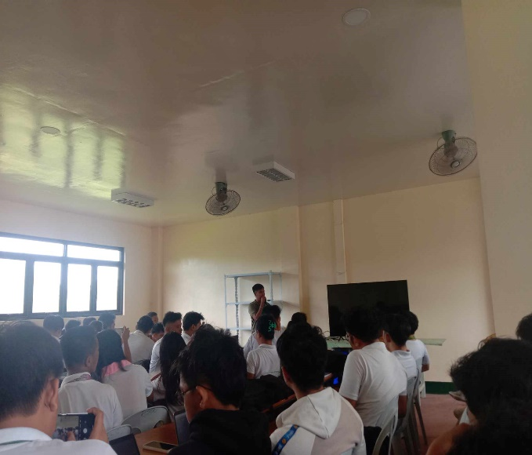**Session 1:** Self-Introduction of the speaker Sir. Armil Garol, he talked about how he got his previous jobs, his hardships and how he acquired the knowledge and skills to UI Designing, the workshop proceeded with a comprehensive introduction to User Interface (UI) design, where participants learned about the significance of user-centric design, the role of UI in websites, and the principles that guide effective UI design

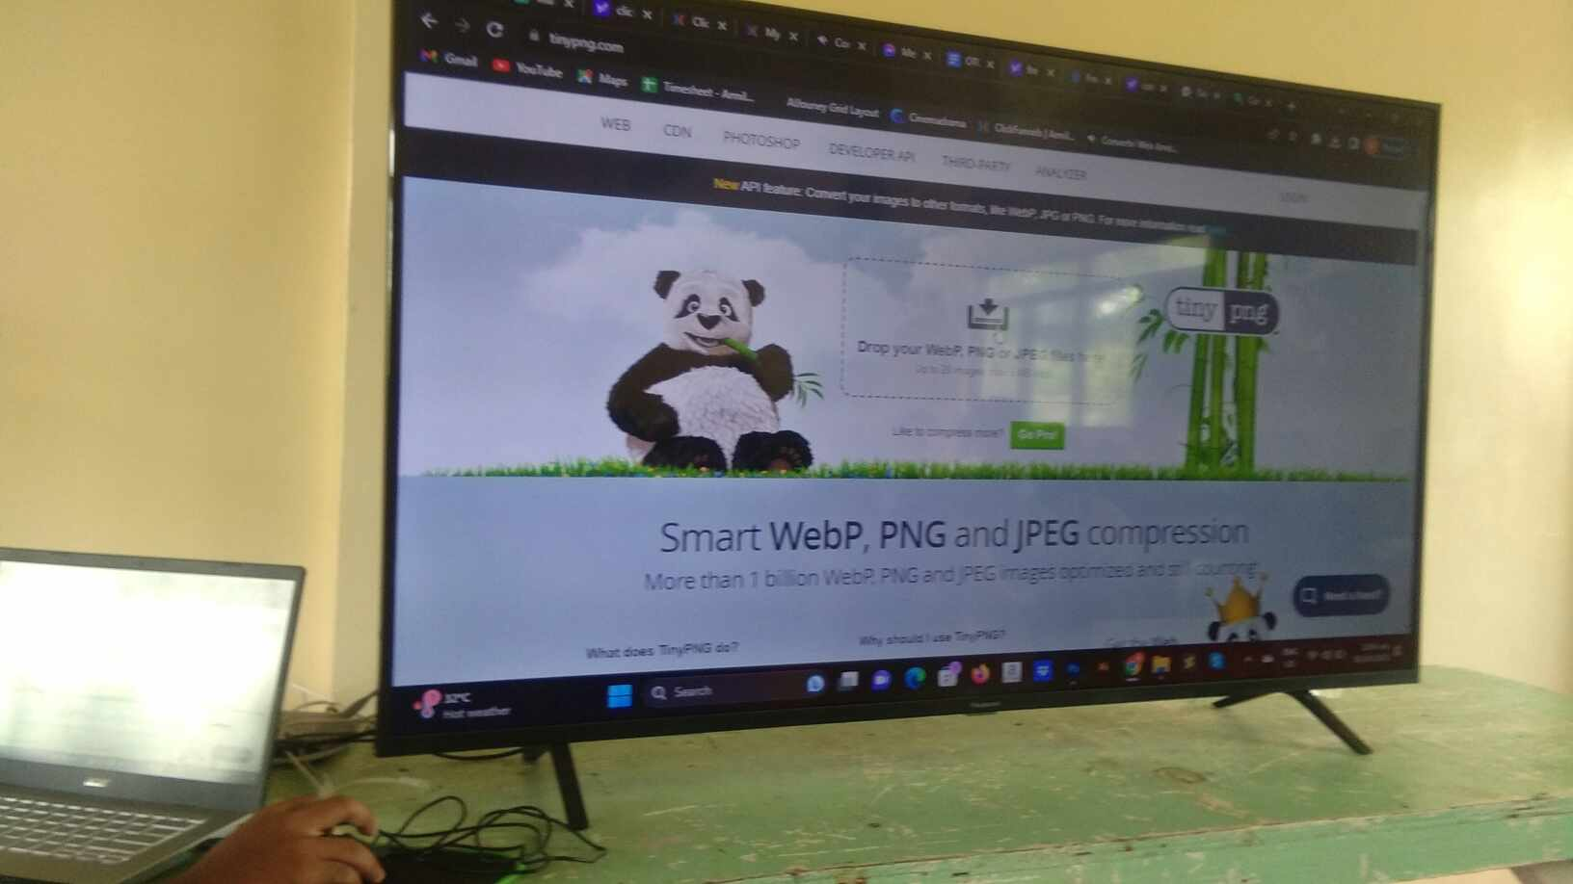

**Session 2:** Design Tools and Software, this session delved into the essential tools and software used in UI design, including Adobe photoshop and an AI tool. Participants received hands-on experience with these tools to create mockups.

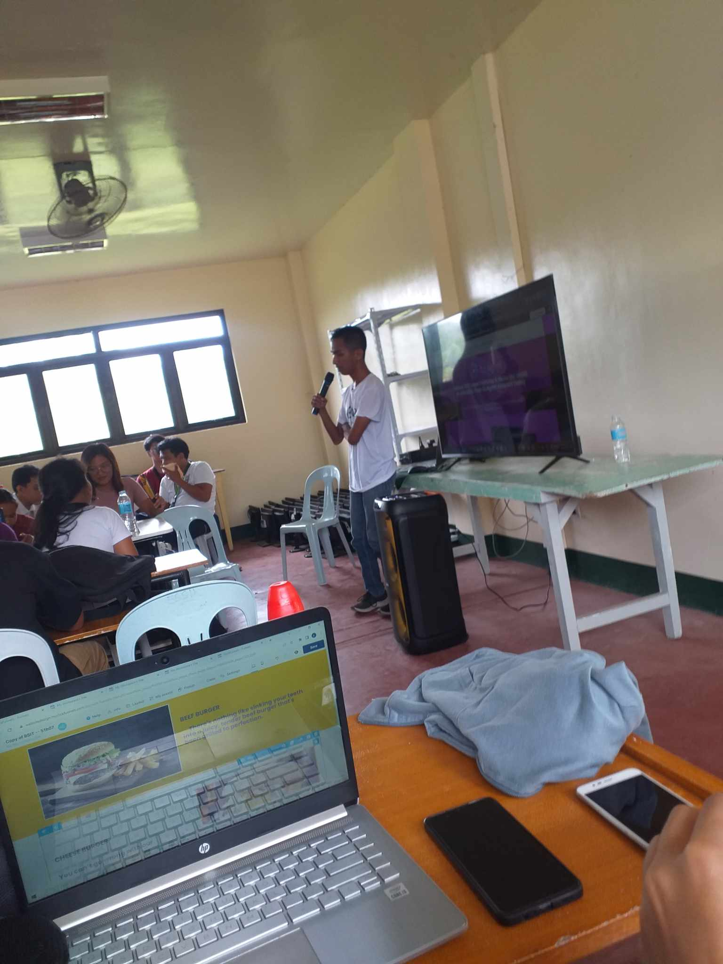

**Session 3:** Wireframing and Prototyping, we students were guided through the process of wireframing and prototyping, where they learned to translate ideas into visual representations. Practical exercises were held to help reinforce these concepts.

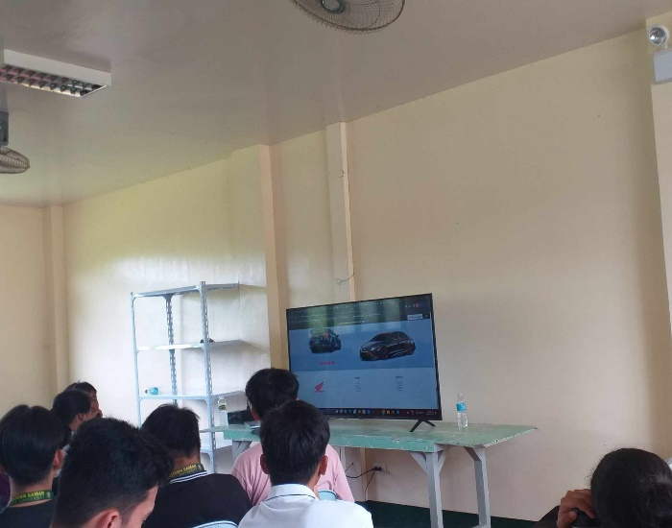

**Session 4:** Final Projects and Presentation To culminate the workshop, we worked on our designated UI design projects, applying the knowledge gained throughout the workshop. Then presented the projects, then received constructive feedback.

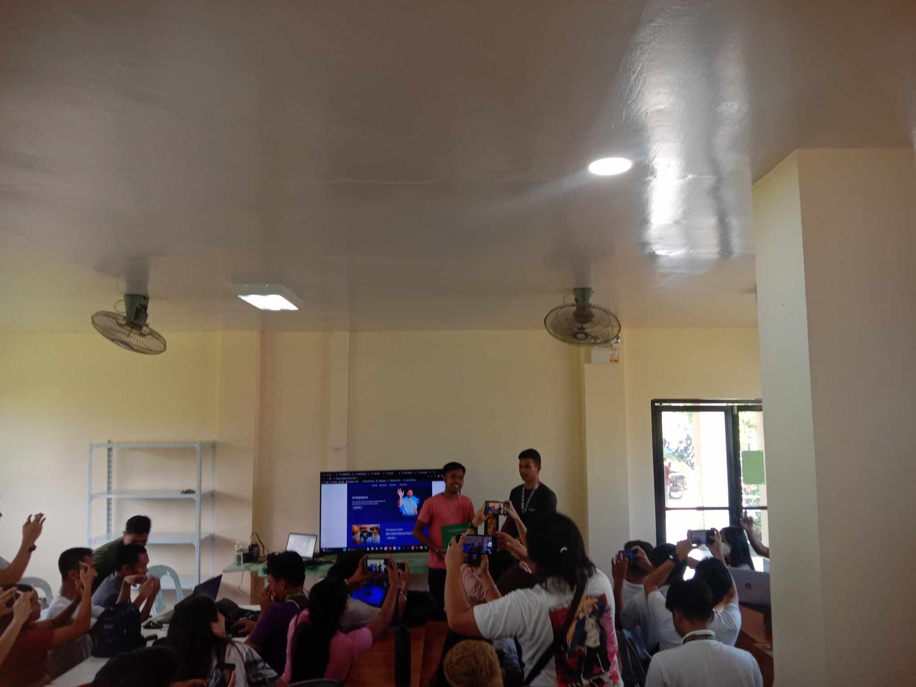

**Session 5:** End of workshop, after two not very short but knowledgeable days the workshop has ended with everyone gaining knowledge and skills that might be used as their advantage for their future career paths.